Table of Contents

Table of Contents

1 Introduction about Liferay Portal 2
2 Introduction about Portlet 2
3 Concepts 2
3.1 Users 2
3.2 Groups 2
3.3 Roles 2
3.4 Organizations 3
3.5 Communities 3
3.6 Permissions 3
3.7 Company 3
4 Setup Extension Environment 3
5 Implement a project 3
5.1.1 Using Ant 3
5.1.2 Using Eclipse IDE 4
5.2 Portlet project 6
5.3 Theme project 6
6 Multi-Languages 6
7 Demo Applications 6
7.1 A website selling mobile-phones 6
7.1.1 Front end 6
7.1.2 Back end 6

Introduction about Liferay Portal
Liferay, Inc. is a professional open-source company that provides free documentation and paid professional service to users of its software. Mainly focused on enterprise portal technology, the company has its headquarters in Los Angeles, California, United States.
Liferay was created in 2000 by Chief Software Architect Brian Chan to provide an enterprise portal solution for non-profit organizations.In 2006, the company was incorporated under the name Liferay, Inc., formalized its Germany subsidiary Liferay GmbH. In 2007, the company opened a new Asian headquarters in Dalian, China and the Spanish subsidiary Liferay SL. In March 2009, the company opened a new office in Bangalore, India.

Introduction about Portlet
Portlets are pluggable user interface software components that are managed and displayed in a web portal. Portlets produce fragments of markup code that are aggregated into a portal page. Typically, following the desktop metaphor, a portal page is displayed as a collection of non-overlapping portlet windows, where each portlet window displays a portlet. Hence a portlet (or collection of portlets) resembles a web-based application that is hosted in a portal. Some examples of portlet applications are email, weather reports, discussion forums, and news.
Portlet standards are intended to enable software developers to create portlets that can be plugged in to any portal supporting the standards.
The Java Portlet Specification (JSR168, JSR286) enables interoperability for portlets between different web portals. This specification defines a set of APIs for interaction between the portlet container and the portlet addressing the areas of personalization, presentation and security

Concepts

Users
Users can be members of organization hierarchies, such as Liferay, Inc ==> Security ==> Internet
Security. They can be collected into arbitrary user groups, such as Bloggers, which would enable them to create blog entries in their personal space. They can be members of communities which draw together common interests. And they can have roles which describe their functions in the system, and these roles can be scoped by Portal, Organization, or Community.

Groups
Groups are simple, arbitrary collections of users, created by administrators.
They can be members of communities or roles. Permissions cannot be assigned to
User Groups. Though User Groups do not have pages like some of the other collections
of users (such as Communities or Organizations), they do have page templates
which can be used to customize users' personal sets of pages. This will be fully described
below

Roles
There are three kinds of roles:
● Portal Roles
● Organization Roles
● Community Roles
These are called role scopes. Roles are used to define permissions across their
scope: across the portal, across an organization, or across a community. For example,
consider a role which grants access to create a Message Board category. A Portal role
would grant that access across the portal, wherever there was a Message Board portlet.
A Community role would grant that access only within a single community. An Organization
role would grant that access only within an Organization.
Users, User Groups, Communities, or Organizations can be members of a role.

Organizations
Organizations are hierarchical collections of Users. They are one of the two types
of portal resources that can have pages. There is also a special type of Organization
called a location, which can define where users are specifically located.
Organizations are handy for defining where a user belongs in a particular hierarchy.

Communities
Communities are collections of Users who have a common interest. Liferay's default
pages are in the Guest community, because everyone—whether they are anonymous
or members of the portal—has a common interest in the default, public
pages of your site. There are three types of Communities:
● Open
● Restricted
● Hidden

Permissions

Company

Setup Extension Environment
The extension environment provides a set of tools based on Apache Ant to develop your own portlets and extension, to modify the configuration and language messages, etc. It also eases the migration to new versions of Liferay Portal. It is meant for those who wish to customize the portal with their own portlets, configuration, etc.
Build Portal source:
ant clean start
Create Extension Environment
ant build-ext
Deploy ext:
Go to ${ext} folder, call:
ant deploy

Implement a project
(With support of "Liferay Plugins SDK" tool)

Using Ant
- Open a Command-line window
- Go to ${liferay-plugins-sdk}\portlets folder, and execute below command:
create <Portlet-Name> <Portlet-Display-Name>
Ex: create "my-demo" "My Demo Portlet Title"
It will create a folder named "my-demo-portlet" (appending '-portlet')
Goto "my-demo-portlet" and execute "ant setup-eclipse" to setup an Eclipse project for it if you want.

Using Eclipse IDE
* Installing Liferay plugin for Eclipse
- Goto Help --> Install New Software
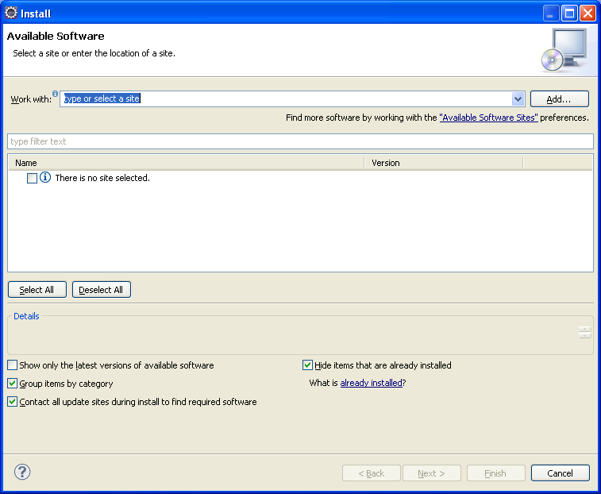
- Click "Add", then input values into the new dialog as below, and click OK:
Name: Any value as you want. Ex: Liferay IDE
Location: http://releases.liferay.com/tools/ide/eclipse/helios/stable
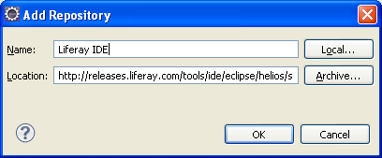
- Follow instructions to finish installing. Remember to restart Eclipse
* Config Liferay Plugins SDK for Eclipse
- Goto Windows --> Preferences --> Liferay --> Installed SDK
- Click "Add" button and point to location of your " Liferay Plugins SDK", give it a name, click OK to finish.
* Create a new Liferay Plug-in project
- Goto menu File --> New --> Liferay Plig-in Project
- Input Project name and Display name
- Plug-in Type: select "Portlet"
- Click Finish
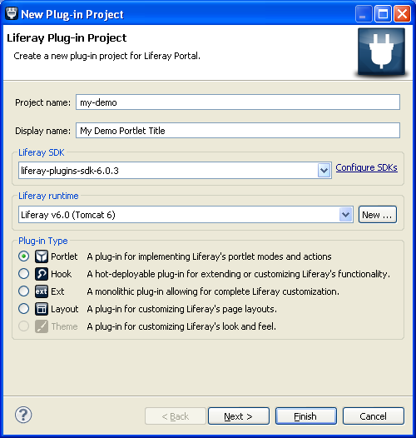

Portlet project

Theme project

Multi-Languages

Demo Applications

A website selling mobile-phones

Front end
- Search phones by price, categories, functions...
- View phone details

Back end
- Add/Edit/Delete categories
- Add/Edit/Delete phones
- Change thame of the website (website has some themes)

